**APPENDIX 1**

**Gas Leakage Monitoring & Alerting System For Industries**

**PROJECT**   **REPORT**

***Submitted by***

**A.S.Elphin Josnell**

**M.Bala Subramanian**

**T.Boobarathi**

**G.Clindon**

***in partial fulfillment for the award of the degree***

***of***

**BACHELOR OF ENGINEERING**

**IN**

**ELECTRONICS AND COMMUNICATION ENGINEERING**

**GOVERNMENT COLLEGE OF ENGINEERING**

**ANNA UNIVERSITY : CHENNAI 600 025**

**NOVEMBER 2022**

**APPENDIX 2**

**ANNA UNIVERSITY : CHENNAI 600 025**

**BONAFIDE CERTIFICATE**

Certified that this project report **“Gas leakage monitoring and alerting system”**is the bonafide work of **“M.Bala Subramanian, A.S.Elphin Josnell, T.Boobarathi, G.Clindon”**who carried out the project work under my supervision.

**SIGNATURE                                                                         SIGNATURE**

**HEAD OF THE DEPARTMENT                                        SUPERVISOR**

                                                                                                         BE

ECE                                                                                               ECE

ECE

Government College of Engineering,Tirunelveli                         ECE

                                                                                                      Government College of Engineering,Tirunelveli

**APPENDIX 3**

**TABLE OF CONTENTS**

1. **INTRODUCTION** 
   1. Project Overview
   2. Purpose
2. **LITERATURE SURVEY**
   1. Existing problem
   2. References
   3. Problem Statement Definition
3. **IDEATION & PROPOSED SOLUTION**
   1. Empathy Map Canvas
   2. Ideation & Brainstorming
   3. Proposed Solution
   4. Problem Solution fit
4. **REQUIREMENT ANALYSIS**
   1. Functional requirement
   2. Non-Functional requirements
5. **PROJECT DESIGN**
   1. Data Flow Diagrams
   2. Solution & Technical Architecture
   3. User Stories
6. **PROJECT PLANNING & SCHEDULING**
   1. Sprint Planning & Estimation
   2. Sprint Delivery Schedule
   3. Reports from JIRA
7. **CODING & SOLUTIONING (Explain the features added in the project along with code)**
   1. Feature 1
   2. Feature 2
   3. Database Schema (if Applicable)
8. **TESTING** 
   1. Test Cases
   2. User Acceptance Testing
9. **RESULTS**
   1. Performance Metrics
10. **ADVANTAGES & DISADVANTAGES**
11. **CONCLUSION**
12. **FUTURE SCOPE**
13. **APPENDIX**

**1.Introduction:**

**a.Project Overview:**

        This project helps the industries in monitoring the emission of harmful gases. In several areas, the integration of gas sensors helps in monitoring the gas leakage. If in any area gas leakage is detected the admins will be notified along with the location. In the web application, admins can view the sensor parameters.

**b.Purpose:**

        Inhaling concentrated gas can lead to asphyxia and possible death.To overcome these disasters, we designed a system for monitoring and alerting the leakage of those harmful gases. This makes the industrialists get rid of the fear of any disasters caused by the gases.

**2.** **Literature**  **Survey:**

**a.Existing Problem:**

       This scheme is meant to fulfill the daily needs of the people. In our country 40 percent people die due to gas explosion at home. That number keeps growing. Even pregnant women and small children are affected.Using a GSM module and a mobile phone, the Gas Leakage Monitor is used to find, intimate leaks. The buzzer and LED are then activated after the gas leak is detected using a bracket sensor. When the designated time has passed, it will automatically turn off.

**b.References:**

      [1] Shital Imade, Priyanka Rajmane, Aishwarya Gavali, V. N. Nayakwadi “Review paper on- LPG Gas leakage detection using IOT”: IJIRS –International Journal of Innovative Research & Studies, Volume 8, Issue 2, Feb 2018 IJIRS: ISSN NO: 2319-9725. [2] Gas Leakage Detection Based on Arduino And Alarm Sound, Rhonnel S. Paculanan, Israel Carino, International Journal of Innovative Technology and Exploring Engineering (IJITEE) Vol 8, April 2019. [3] Dr. Chetana Tukkoji, Mr. Sanjeev Kumar, “Review paper on- LPG Gas leakage detection using IOT”: IJEAST –International Journal of Engineering Applied Science & Technology, Volume 4, Issue 12, April 2020 IJEAST (online): 603-609. [4] Sanjoy Das, Sahana S, Soujanya K Swathi M C, "Gas leakage detection and prevention using IoT", International Journal of Scientific Research % Engineering Trends. Vol 6, Issue 3, May-June 2020, ISSN (online): 2395-566X. [5] Amatul Munnaza, Rupa Tejaswi, Tarun Kumar Reddy, Saranga Moahan “IoT Based Gas Leakage Monitoring Syste”, Journal of Xi’an University of Architecture & Technology,Vol 12, ISSN No: 1006-7930, Issue 5, 2020. [6] B. F. Alshammari, M. T. Chughtai, “IoT Gas leakage detector and warning generator”. Engineering and Technology and Applied Science Research Volume 10, Issue August 2020 .6142-6146. [7] Gas Leakage Detection and Prevention System, Shreyas I Thorat, Neha Tonape, International Journal of Trendy Research, Vol 4, Issue 7, Dec 2020, ISSN NO: 2582-0958. [8] Rohan KH1, Navanika Reddy, Pranamya Maddy, Sachit Girish, Dr. Badari Nath K “IOT based gas leakage detection and Alerting system”: JRP Publications,Vol. 1(1), pp. 002- 006, February 2021. [9] D. Surie, O. Laguionie, T. Pederson, “Wireless sensor networking of everyday objects in a smart home environment”, Proceedings of the International Conference on Intelligent Sensors”, Sensor Networks and Information ProcessingISSNIP- 2008, pp. 189 – 194. REFERENCE: [10] J. Tsado, O. Imoru, S.O. Olayemi, “Design and construction of a GSM based gas leak Alert system”‖, IEEE Transaction,IRJEEE Vol. 1(1), pp. 002-006, September, 2014. [11] M. Eisenhauer, P. Rosengren, P. Antolin, “A Development Platform for Integrating Wireless Devices and Sensors into Ambient Intelligence Systems”, pp.1- 3. [12] Harshada Navale, Prof. B.V.Pawar, “Arm Based Gas Monitoring System”. International Journal of Scientific & Technology Research Volu me 3, Issue 6, June 2014. [13] Byeongkwan Kang,Sunghoi Park,Tacklim Lee andSehyun Park, "loTbased Monitoring System using Tri-level Context Making Model for Smart Home Services", 2015 IEEE International Conference on Consumer Electronics (ICCE), 2015. [14] Abhishek, P. Bharath, “Automation of lpg cylinder booking and leakge monitoring system,” International Journal of Combined Researchand Development (IJCRD), pp. 693–695, 201

**c. Problem statement definition:**

           This device does not get damaged very quickly, and if it does get damaged, water is the main reason for it. This device is easily damaged by water. Therefore, this device should be installed in a place where water does not go. This installation will not damage the device, if the device does, an example is water. This tool is considered to be one and very safe for the users. My members are trusted. My members' invention is considered very safe for this country and its people and their families. Absence of this tool makes women in our country nervous by the spread of gas in their kitchen and is considered to be a sign of some accident. It is also proud to think of this project for people's lives only to eliminate this fear.

**3.**  **Ideation**  **& Proposed solution:**

**a.Empathy map**

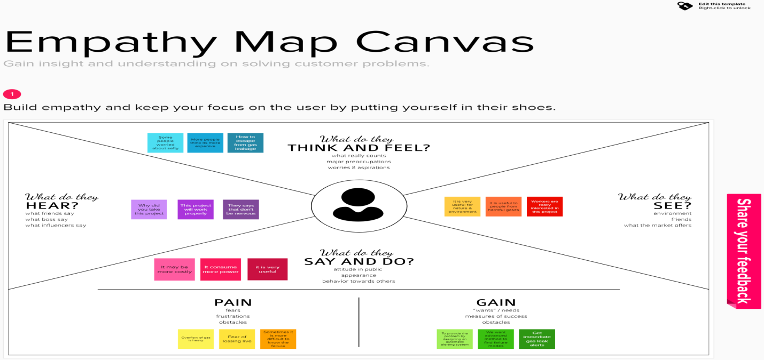

**b.Ideation and Brainstorming**

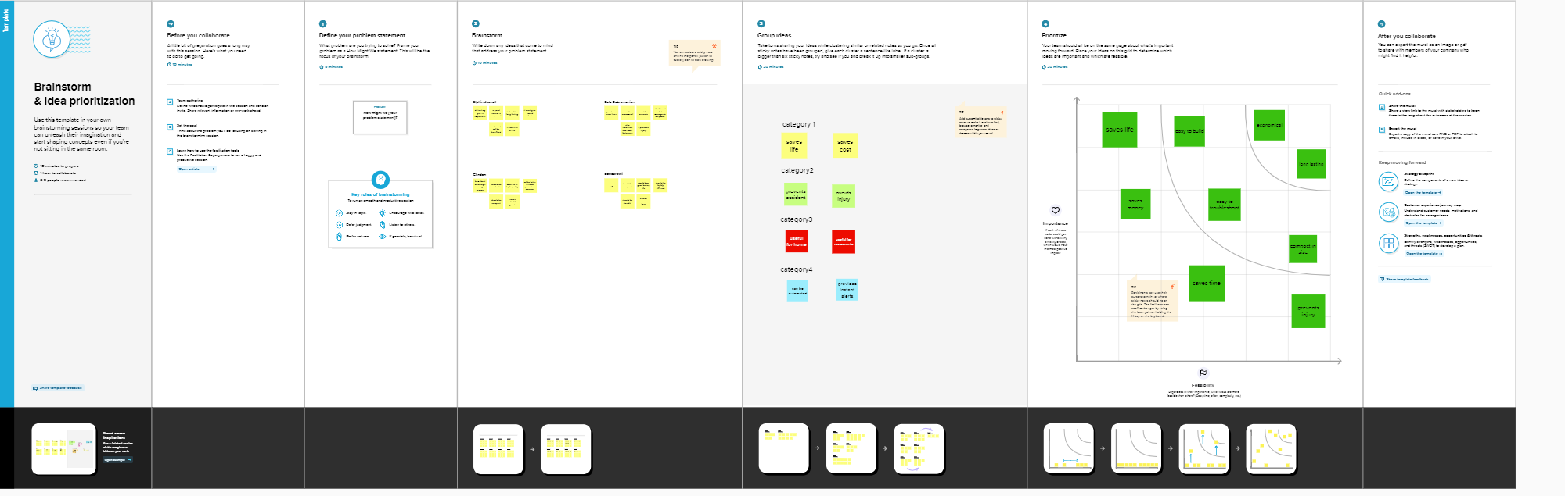

**c.Proposed solution**

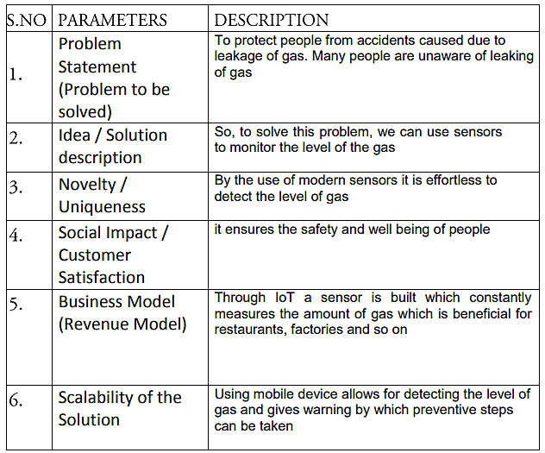

**d.Problem Solution Fit**

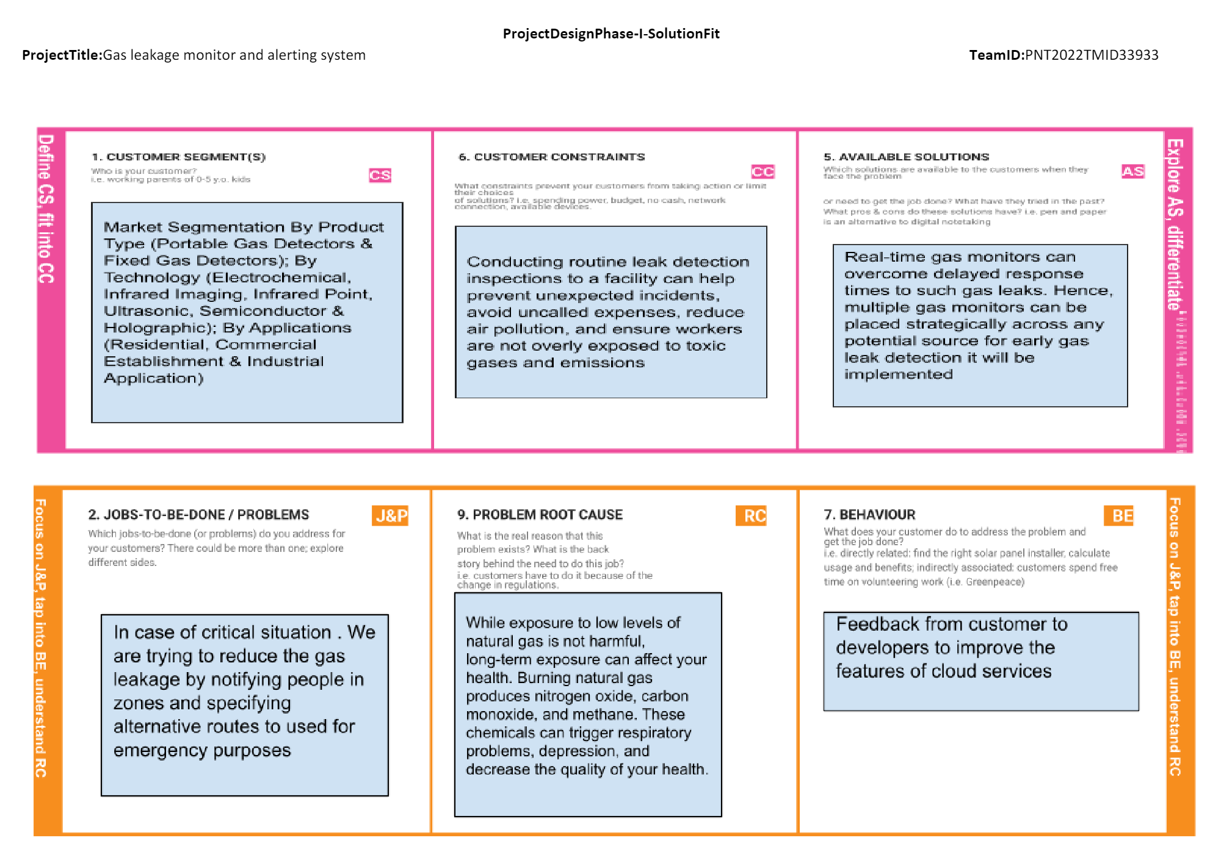

**4.**  **Requirement Analysis:**

**a.**  **Functional Requirements**

             The following are the functional requirements and non functional requirements

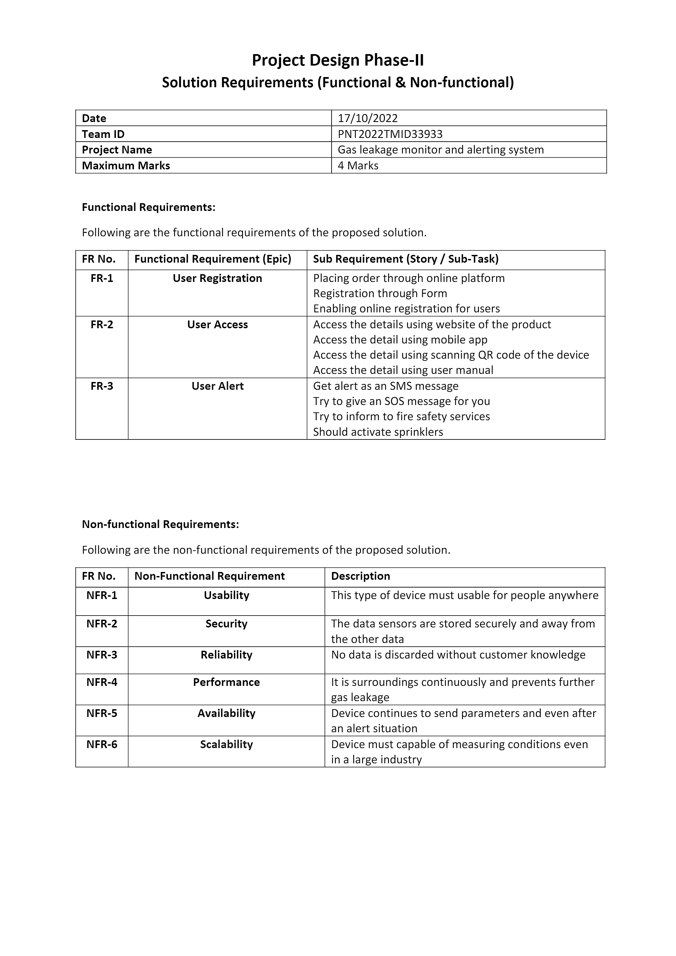

**b.Non-Functional requirement**



**5.**  **Project Design:**

**a.** **Data Flow Diagram**

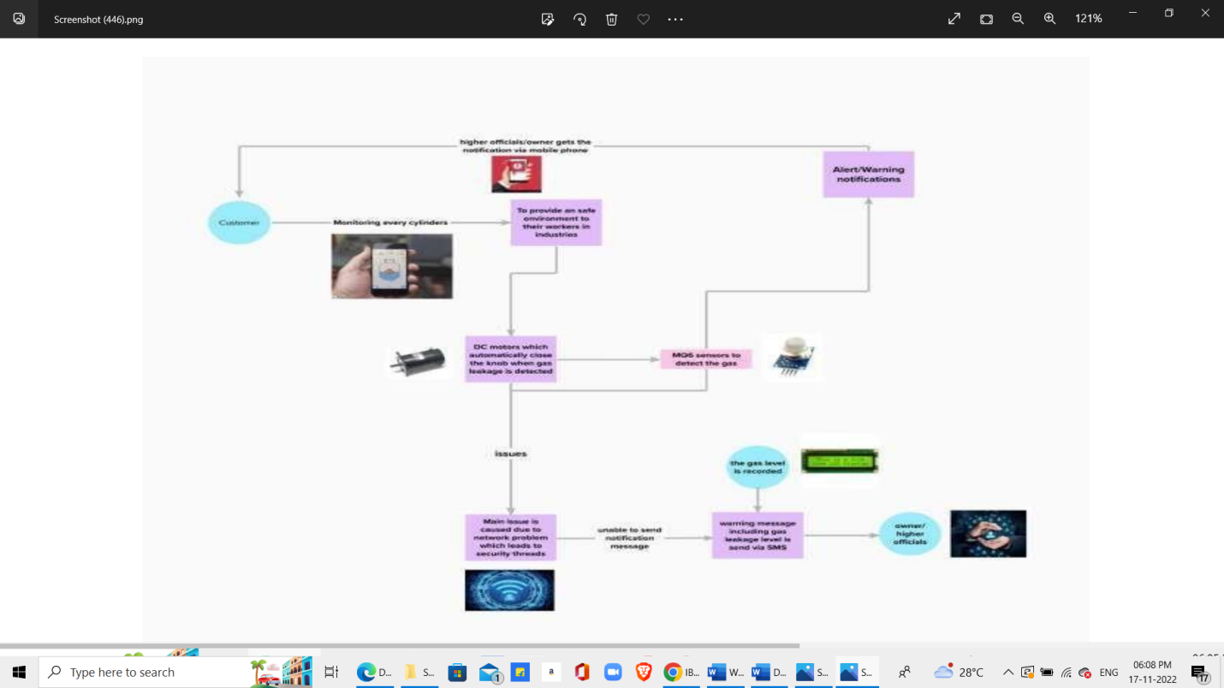

**b.Solution and Technical Architecture**

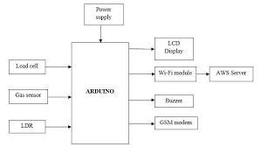

**c.**  **User Stories**

Use the below template to list all the user stories for the product. User Type Functional Requirement (Epic) User Story Number User Story / Task Acceptance criteria Priority Release Worker in industry Gas detection design coverage USN-1 Area Coverage for Gas Detectors Like smoke detectors, a gas detector is capable of providing up to 75SQM area coverage based on a 5M radius of operation. Design coverage measures the percentage of test cases coverage against the number of requirements High Sprint-1

Owner in industry Leak detection USN-2 In industrial settings leak detection is a routine procedure that is necessary for monitoring product movement. To detect leaks in fluid system such as piping network and pressure vessels High Sprint-1

Owner in industry Gas detection actions USN-3 A gas detection system is usually connected with an alarm system, so as soon as the potentially dangerous gas is detected, the alarm is set to ON automatically, which warns the workers in time to safely evacuate. Gas detection systems are used to monitor and either alarm or be part of processing control Low Sprint-2 Worker in industry Gas detection location USN-4 A gas detection sensors should be located near the floor for gases or vapors three or four times heavier than air. They should be installed near the ceiling orroof to detect lighter-than-airgases. To detect install your natural gas detectors in locations close to sources of natural gas.

Medium Sprint-1 Worker in industry Gas detection levels USN-5 A gas detection levels programmed, typically 10-20% LEL for a first alarm (warning) and 20-40% LEL for a second stage alarm to evacuate or take further action Gas detection level shows the percentage within a safety range of 0-10% of the Lower Explosive Limit (LEL) and, ideally, should read 0% High Sprint-1 Worker in industry Gas detection calibration USN-6 A gas detection calibration must be traceable to a national or international standard in order to be considered accurate for calibration. Calibration is recommended annually or if bump testing indicatesan out of spec sensor High Sprint-1

**6.Project Planning and Scheduling:**

**a.Sprint Planning and Estimation**

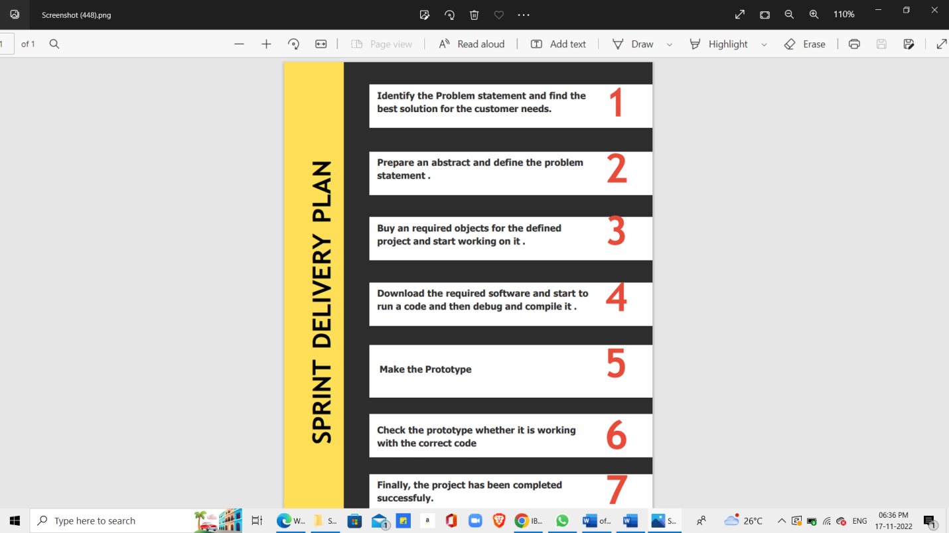

**b.**  **Sprint Schedule**

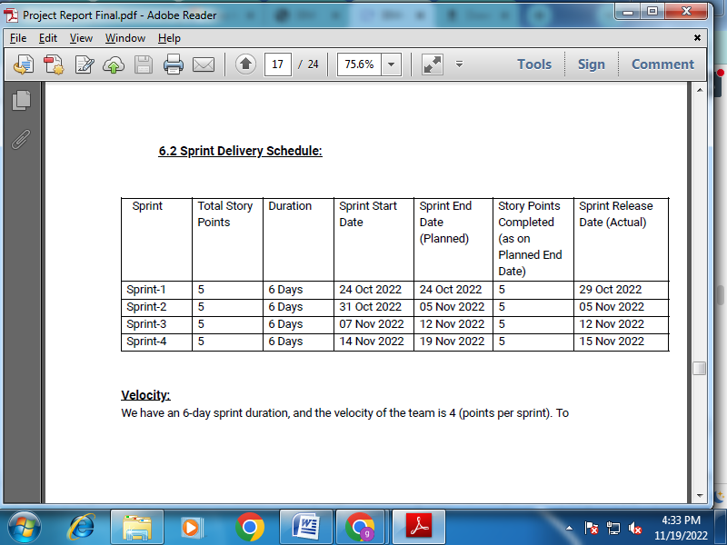

**7.Coding and Solutioning**

**a.Feature-1**

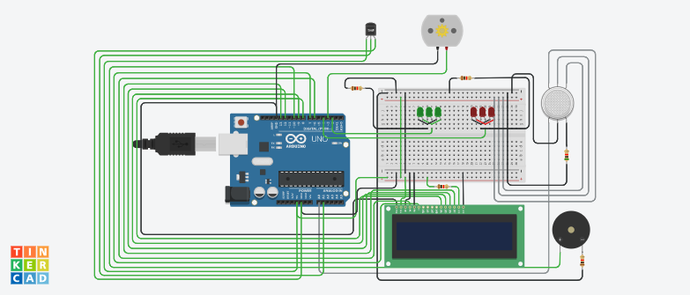

1. Connect LCD ground, contrast, and LED cathode to ground

2. Connect LCD anode to 1k ohms resistor, then to the positive power rail

3. Connect LCD power to the positive power rail

4. Connect LCD register select to Arduino pin 5

5. Connect LCD read/write to ground

6. Connect LCD enable to Arduino pin 6

7. Connect LCD terminal to Arduino pin

**b.Feature-2**

#include LiquidCrystal lcd(6,7,8,9,12,13);

float tempsensor=A1;

void setup() { pinMode(2,OUTPUT);

pinMode(4,OUTPUT);

pinMode(10,OUTPUT);

pinMode(3,OUTPUT);

pinMode(A0,INPUT);

pinMode(A1,INPUT);

Serial.begin(9600);

lcd.begin(16,2); } void loop() { { float temp=analogRead(tempsensor);

Serial.println(temp);

if(temp>150) digitalWrite(3,HIGH);

else digitalWrite(3,LOW); } int analogValue = analogRead(A0);

Serial.print(analogValue);

if(analogValue>400) { digitalWrite(4,HIGH);

digitalWrite(2,LOW);

tone(10,10000,100000);

lcd.clear(); lcd.setCursor(0,1);

lcd.print("WARNING");

delay(1000);

lcd.clear();

lcd.setCursor(0,1);

lcd.print("GET OUT");

delay(1000); } else { digitalWrite(2,HIGH);

digitalWrite(4,LOW);

noTone(10);

lcd.clear();

lcd.setCursor(0,1);

lcd.print("EVERYTHING IS CLEAR");

delay(1000);

lcd.clear();

lcd.setCursor(0,1);

lcd.print("SAFE NOW");

delay(1000);

}

}

**8.Testing**

**a.Testing of Cases**

                 Most industries use the manual sorting process to sort consumer goods production. The problem of manual sorting is taking a long time to complete the work. The industry should be demanded to be faster and more efficient in meeting consumer needs. The purpose of this research is to make a tool that can sort goods automatically into the warehouse using RFID technology by combining Arduino and PLC as the controller. The number of items that have been sorted can be monitored remotely by using the Internet of Things (IoT). By identifying the items using RFID makes work more concise and efficient. This research uses an experimental method. The automatic sorting system uses an RFID reader to read ID cards that have been installed on the goods side. The ID cards are processed into Modbus data to be sent to the PLC Siemens S7-1200 via Ethernet Shield that is connected to the Arduino Mega 2560. The PLC will select items to be placed on each conveyor. The results of this study showed that the system can work automatically in the sorting of consumer goods and can monitor the process of its work system on the GOIOT platform via the internet network.

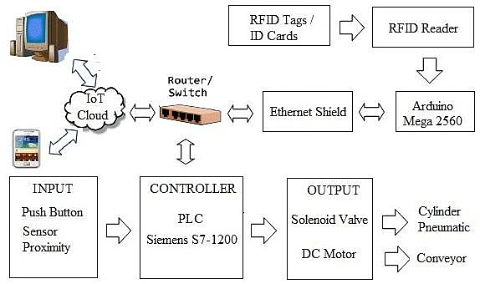

**b.User Acceptance &Testing**

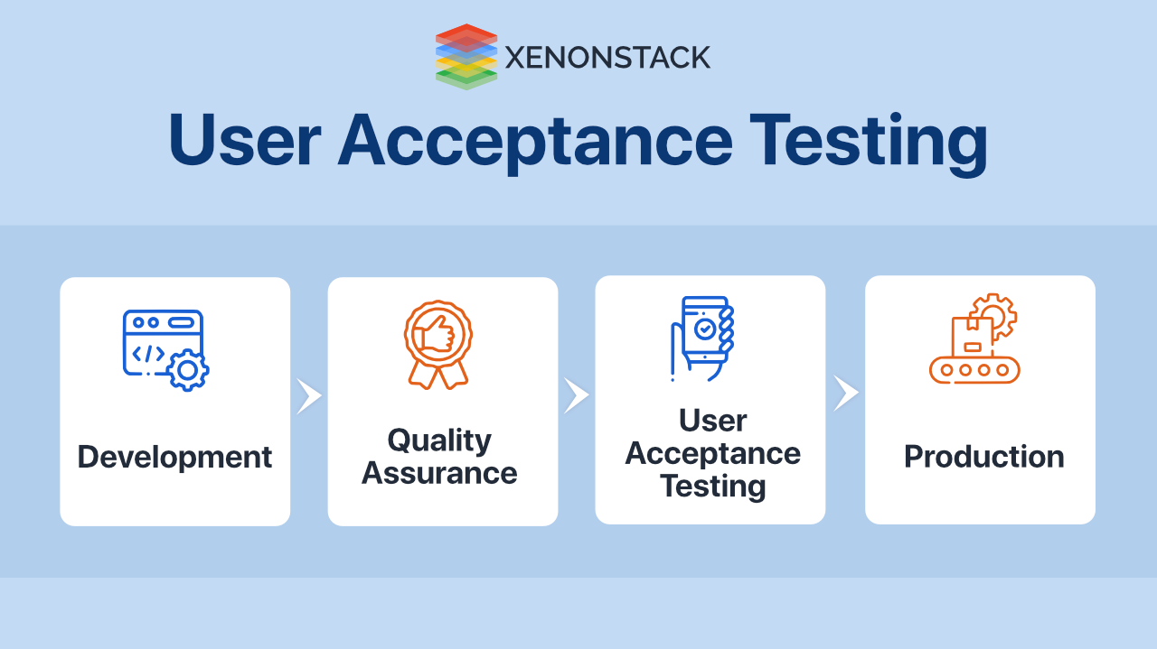

**9.Results**

**Performance Metrics**

 The system's performance is determined by its accuracy.  It should detect leakage as soon as possible. It should be sensitive towards leakage and should be reliable.

**10.Advantages and DIsadvantages:**

**Advantages**

● Detect the concentration of the gases

● The sensor-enabled solution helps prevent the high risk of gas explosions and

affecting any casualties within and outside the premises.

● Get real-time alerts about the gaseous presence in the atmosphere

● Prevent fire hazards and explosions

● Ensure worker’s health

● Real-time updates about leakages

● Cost-effective installation

● Measure oxygen level accuracy

● Get immediate gas leak alerts

**Disadvantages**

* Get immediate gas leak alerts
* When heavy dust, steam or fog blocks the laser beam, the system will not

be able to take measurements

**11.Conclusion**

         As this brief overview shows, the gas sensor industry has developed a number of different technologies, each of which has strengths and weaknesses for use in specific applications. All manufacturers share a common purpose in improving the effectiveness of life and property protection in potentially dangerous environments. Advances in sensor design are generally aimed at producing faster response, greater specificity, better stability, longer life and greater reliability. In capital-intensive industries such as the chemical sector, which produces toxic, corrosive, explosive and flammable gases as a matter of routine, plant protection rightly has a very high priority. Add in the duty of care to the workforce, a reduction in emissions to reduce environmental damage and the need to prevent leaks that could affect the local population, the benefits from using today's gas detection advanced technology have never been more obvious. Thinking about new products & solutions which would make this world better to live.

**12.Future Scope**

              Major cities of India are pushing Smart Home application, gas monitoring system is a part of Smart Home application. Enhancing Industrial Safety using IoT. IoT turns drone into gas detection sensor. Another major future scope could be including a Automatic Shut-off device which will turn off the gas supply whenever it will detect any gas leakage. This system can be implemented in Industries, Hotels and wherever the LPG cylinders are used. This system can be used in industries involving applications such as Furnace, Boilers, Gas welding, Gas cutting, Steel Plants, Metallurgical industries, Food processing Industries, Glass Industries, Plastic industries, Pharmaceuticals, Aerosol manufacturing. As hospitals require to provide maximum possible safety to patients, this system can be used to keep track of all the cylinders used in it. Some of the cylinders used are Oxygen cylinder, Carbon dioxide cylinder, Nitrous oxide cylinder. As many students are naïve the risk of causing accidents is high. Hence, our system can also be used in schools, colleges. Many colleges have well established labs including chemistry lab and pharmaceutical labs where gas burners are used. Plenty of medical equipment requires gas cylinders.

**13.Appendix:**

**a.Source Code**

#include LiquidCrystal lcd(6,7,8,9,12,13);

float tempsensor=A1;

void setup() { pinMode(2,OUTPUT);

pinMode(4,OUTPUT);

pinMode(10,OUTPUT);

pinMode(3,OUTPUT);

pinMode(A0,INPUT);

pinMode(A1,INPUT);

Serial.begin(9600);

lcd.begin(16,2); } void loop() { { float temp=analogRead(tempsensor);

Serial.println(temp);

if(temp>150) digitalWrite(3,HIGH);

else digitalWrite(3,LOW); } int analogValue = analogRead(A0);

Serial.print(analogValue);

if(analogValue>400) { digitalWrite(4,HIGH);

digitalWrite(2,LOW);

tone(10,10000,100000);

lcd.clear(); lcd.setCursor(0,1);

lcd.print("WARNING");

delay(1000);

lcd.clear();

lcd.setCursor(0,1);

lcd.print("GET OUT");

delay(1000); } else { digitalWrite(2,HIGH);

digitalWrite(4,LOW);

noTone(10);

lcd.clear();

lcd.setCursor(0,1);

lcd.print("EVERYTHING IS CLEAR");

delay(1000);

lcd.clear();

lcd.setCursor(0,1);

lcd.print("SAFE NOW");

delay(1000);

}

}

**b.GitHub Link**

<https://github.com/IBM-EPBL/IBM-Project-32800-1660212143>

**c.Demo Link**

<https://drive.google.com/file/d/1f3yHKbxIL61pxNUHZjprjIUWYexd2U28/view?usp=drivesdk>

**d.Tinkercad Link**

<https://www.tinkercad.com/things/fiKQbQb3BRc?sharecode=K8fo3_1Y96Pmpst6Bq7UFtpCacsx8nZf4XNVDMPz5l4>